ALEJANDRO SANTORUM VARELA – EDAT 5th HAND IN – 13/12/2017

EXERCISE 42:

a) Does it make sense to store the relation data using ﬁxed-length records?
Yes it does, because all the fields of Reservation seem like they have all the same lenght.

b) Assuming that RESERV ATION data is stored using ﬁxed-length records:
  - Cancel Maria’s reservation.
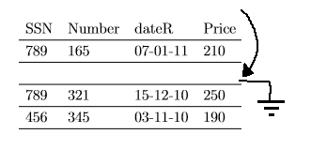
  - Cancel Pedros reservation.
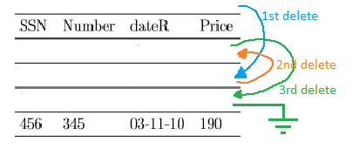
  - Book a ticket for Maria in the ﬂight 321 on 23th-Oct-2010, price=200.
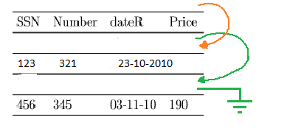

EXERCISE 43

a) Insert a 300 byte register.

300 → 200 → 100 (we insert in the block of 500 free bytes and then it is reorganized.)

b) Delete a 250 byte register.

300 → 250 → 200 → 100

c) Insert a 400 byte register.

300 → 250 → 200 → 100 (It is not capable of insert 400 bytes because of lack of space, it should check in another place if it fixes).

EXERCISE 45

a.a) 60s/15000 = 4ms time that it needs to read a track = 4 ms it´s the time that it needs to read 500 sectors.
5M of records = 20 * 10^8 bytes
1 sector = 1000 bytes
20*10^8/1000 = 20*10^5 sectors have to be read.
(20*10^5/500)*4 ms = 16000ms = 16s

a.b) same time because we are supposing the file is stored in contigous clusters.
16s

a.c) same time because we are supposing the file is stored in contigous clusters.
16s.

b.a)
8ms * 5M = 40M ms thats the time wasted searching each time for the new place to read. In addiction, we have to sum now the rotational delay.

b.b) 5M/400000 = 12,5 times that we have to search the place to read again, SO we need 12,5 * 8ms = 100 ms. In addiction, we have to sum the rotational delay.

b.c) 8ms + rotational delay

